ELCT Press Release
Date: August 15, 2016
Press release No. 002/08/2016

Women pastors commemorate their 25th anniversary in Tanzania
By Elizabeth Lobulu
Recently 34 Women pastors in the Northern Diocese commemorated the 25th anniversary since the Evangelical Lutheran Church in Tanzania (ELCT) endorsed the ordination of women. The Diocese has 34 women pastors out of 250 women pastors in the whole church.
They organised a two-day workshop and retreat. A Church service held on the 7 August 2016 marked the climax of their celebrations that included launching of a book entitled: “Yubile ya Miaka 25 ya Huduma ya Wachungaji Wanawake.” (The Silver Jubilee of Women Pastoral Ministry).
The idea of having the celebration came from eight Pastors, namely: Rev. Dr. Rose Materu, Rev. Sarah Urassa, Rev. Vera Luice Mtei, Rev Anna Makyao, Rev. Sr. Elly Urio, Rev. Joyceline Njama, Rev. Martha Usiri and Rev. Emeline Ndosi. They were full of praise and thanks giving to God for opening up the opportunity for them to study theology. Each had a story to tell about the journey they took in the pastoral ministry in the ELCT.
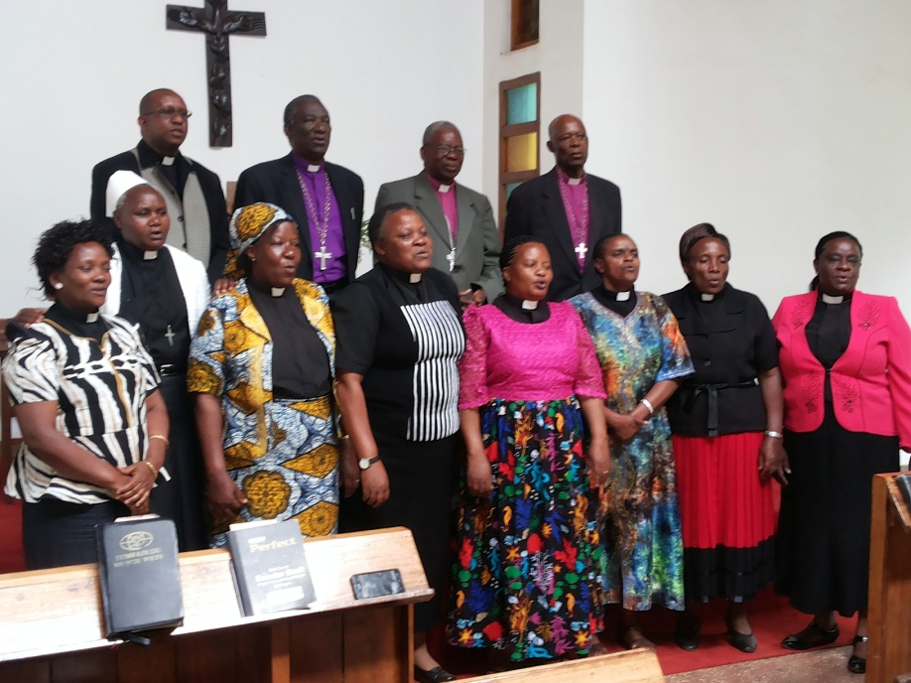
The women pastors who organised the celebration pose for a photo with current and past leaders of the Northern Diocese.
Past and current leaders of the diocese spoke to the participants who included leaders of the diocese, women pastors and invited guests. The ELCT Deputy Secretary General for Social Services and Women’s Work, Rev. Rachel Axwesso, also attended as part and parcel of the 34 women pastors in the Diocese.
The ELCT Presiding Bishop Dr. Fredrick Shoo who is also the current Bishop of the Northern Diocese echoed what was said by his predecessors – Retired Bishop Dr. Martin Shayo and Retired Bishop Dr. Erasto Kweka - that having women pastors was a blessing to the pastoral ministry in the Church.
This was corroborated by Martha Massawe, an invitee theologian from Mbulu Diocese who said “the vision of leaders of the diocese to train theologians although there were no women pastors in the church at the time was a miracle.”
Those who had time to relive their experience during the retreat said in the past some of the male students in theology classes were openly against women ordination. They questioned “if the bishops who sent women to study theology did not have other candidates,” meaning men.
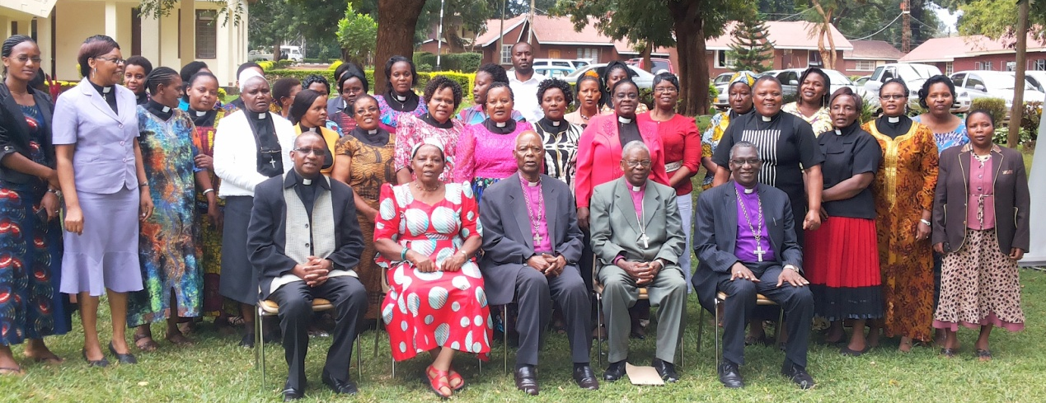
A group photo after the opening session at Uhuru Hotel in Moshi. (Photo by Philemon Fihavango, RSYI).
A participant said some pastors were not welcome in some parishes simply because they were women or they were given a lower salary compared to their male counterparts. But with time women pastors were treated equitably.
Leading a sermon during the Church service, Dr. Elieshi Mungure, the Secretary for Africa in the Lutheran World Federation (LWF), urged the Church leadership to ensure it draws on board women theologians as co-workers in the pastoral ministry of the church. She also thanked the Church for her active role in the wider Lutheran communion in Africa and globally as a member of the LWF.
History was in the making in the late 1980s when ELCT units in every corner initiated debates on whether women theologians should be ordained or not. Very few women had studied theology by then.
It was not an easy debate as it required a lot of patience and tact in handling the issue.
To cut a long story short, the ELCT Assembly held in Morogoro 9 – 14 July 1990 endorsed the decision to ordain women to become pastors. The assembly directed the dioceses to work out how they were to implement the decision.
Following the historical decision the late Rev. Tuseline Madembo became the first woman theologian to be ordained pastor in Iringa Diocese on 20 January 1991 followed by the ordination of three women theologians in the North Eastern Diocese on 30 June 1991 and six women theologians were ordained on 4 August 1991 in the Northern Diocese. The Church has 274 women pastors and theologians out of more than 2,000 pastors.
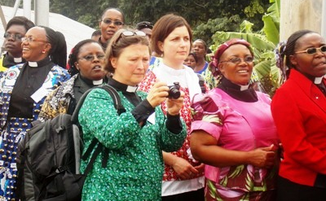 | Some of the 174 women pastors and theologians who were in Bukoba for a church wide celebration to mark 25 years since the decision to ordain women made by ELCT Assembly.
Women theologians met for a consultation in Bukoba 12 -17 May 2015 to celebrate the 25th anniversary since the decision to ordain women was made and in particular to honour Pastor Alice Kabugumila, from the North Western Diocese for waiting for 33 years before her ordination could take place.
Pastor Alice Kabugumila was the first woman theologian in Africa who studied 1969 - 1973 and awarded a Certificate in Theology by the then Lutheran Theological College Makumira (Now Tumaini University Makumira), however, her ordination took place in 2006.
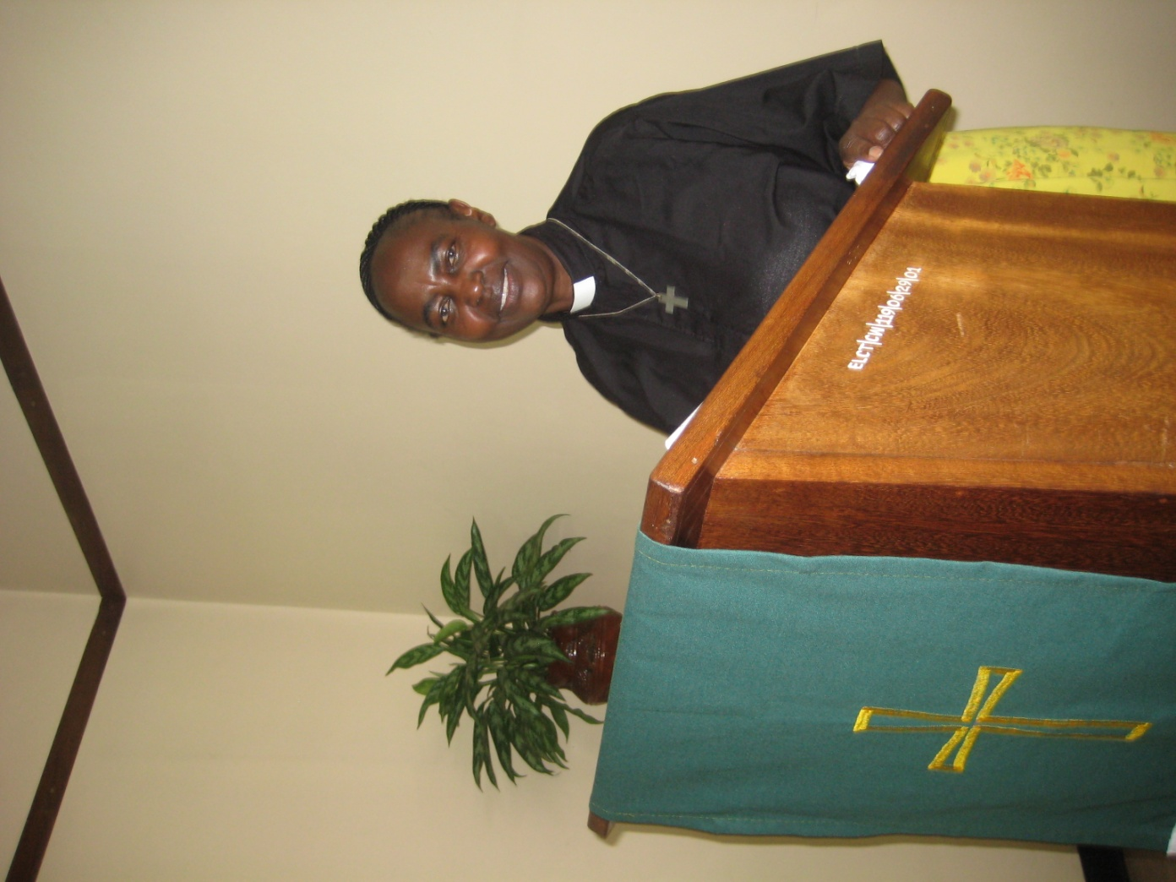Pastor Alice Kabugumila, the first woman theologian in Africa.
At least 170 women pastors and theologians attended the women consultation in Bukoba. The participants urged the Diocese in Mara region and Mbulu Diocese to ordain women theologians as agreed upon by the August ELCT Assembly in 1990.

