ELCT Press Release
Date: July 21, 2014
Press release No 001/07/2014

ELCT Women and youth gather for their assemblies
The following is a pictorial presentation of the two gatherings that took place at the same time in different venues. The first event is the Women Assembly held at Kibaha District while the second is the Youth Assembly held at Olasiti Garden Resort in Arusha.

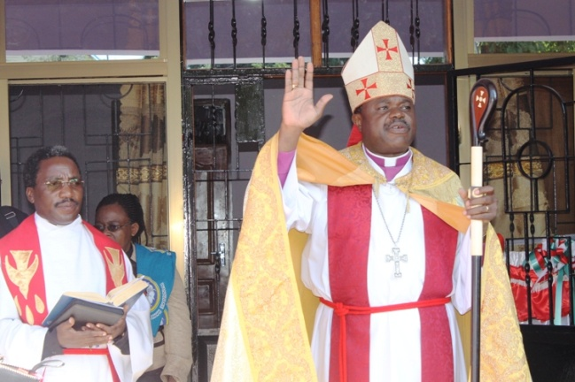 | The ELCT Women Assembly held 8 – 13 July this year at Mkuza Girls Secondary School in Kibaha District was opened and closed by the ELCT Presiding Bishop, Dr. Alex Malasusa who is also the Bishop of the ELCT Eastern and Coastal Diocese (ECD). Looking on is District Pastor Rev. Jacob Mwangomola - Western District, ECD (PHOTO © UPENDO NEWSPAPER/ EMMANUEL KIMWERI)

Some of the 100 participants who attended the opening session of the ELCT Women Assembly with a theme: “Take heed, be quiet, do not fear, and do not let your heart be faint,” Isaiah 7: 4 | 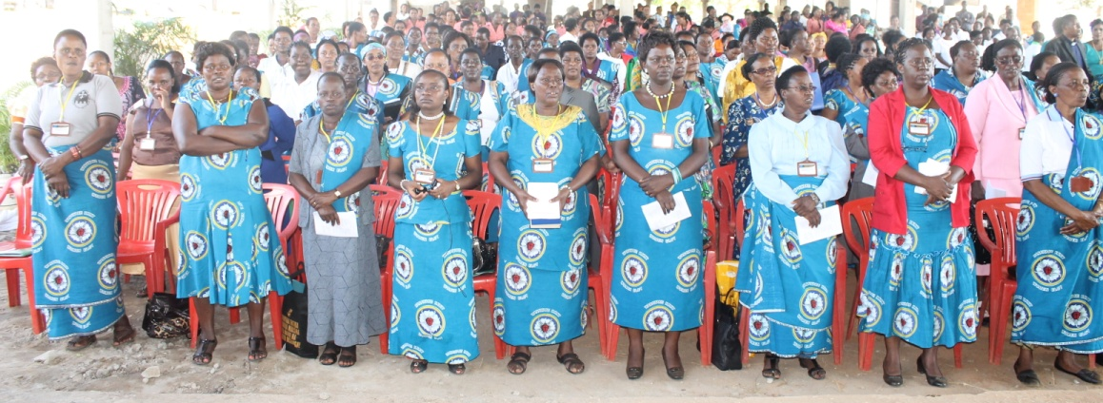

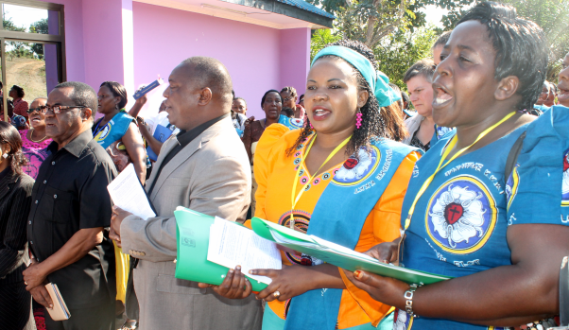 | 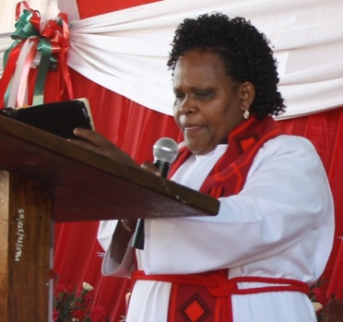 | 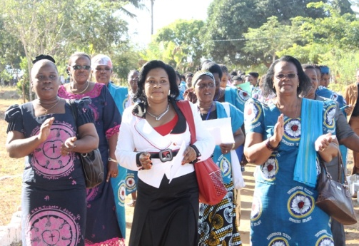
Ambassador Richard E. Mariki the General Secretary (L) and Dean George Paul Fupe of ELCT Eastern and Coastal Diocese followed by Mrs Faustina Nillan the ELCT Director for Women and Children’s Work Director and Mrs Monica the outgoing Chairperson of ELCT Women’s Work. | Rev. Rachel Axwesso the ELCT Deputy Secretary General for Social Services and Women’s Work led the Bible Study on the Women Assembly theme: Isaiah 7: 4 | Mrs Ericah Malasusa the wife of the Presiding Bishop was among those who took part in the procesession just before the opening of the Women Assembly. (PHOTO © UPENDO NEWSPAPER/ EMMANUEL KIMWERI)

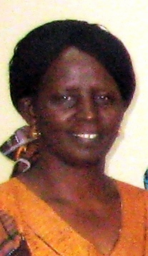 | 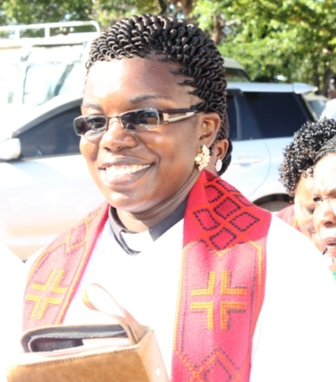 | 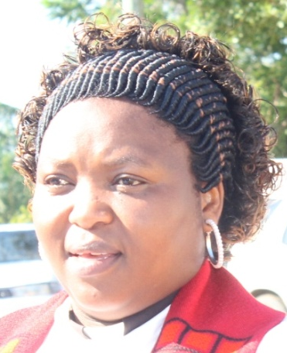
Mrs Mary E. Laiser the newly elected Chairperson of ELCT Women’s Work from ELCT North Central Diocese. | Rev Leita Mwakilima the Vice Chairperson ELCT Women’s Work from ELCT Eastern and Coastal Diocese. | Rev Dr. Hoyce Mbowe presented a paper on Women and Leadership during the Women Assembly.
Both events were graced by the presence of ELCT leaders. The ELCT Secretary General, Mr. Brighton Killewa, gave a speech during the Youth Assembly.

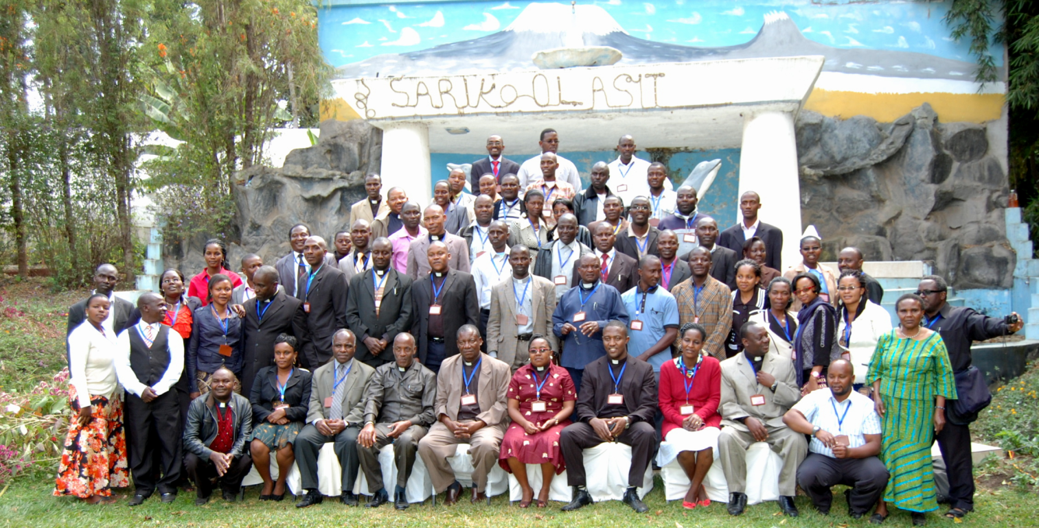
Group picture of ELCT Youth Assembly participants and Leaders at Olasiti Resort in Arusha. (Photo by Maduka Maduka of Arusha)

The Youth Assembly was opened by Rev Solomon Massangwa, Bishop-elect of North Central Diocese while Bishop Dr Paulo Akyoo of ELCT Meru Diocese presented a paper on the Role of A Christian Youth in Serving the Church.
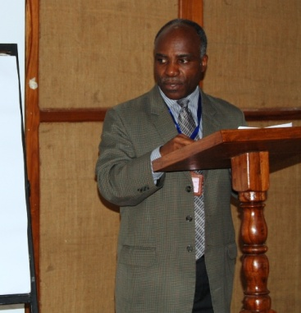 | 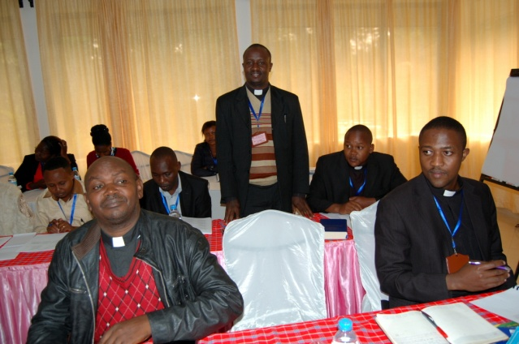 | 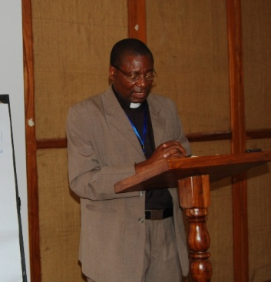
Mr. Brighton Killewa, the ELCT Secretary General addressing the Youth Assembly. | Some of the participants getting introduced. Rev Anza A. Lema the ELCT Youth Coordinator (R) looks on. (Photo by Maduka Maduka of Arusha) | Bishop-elect AmbeleMwaipopo led the Bible Study based on Ephesians 5: 16 at the Youth Assembly.

